Media literacy skills for discovering, evaluating and re-using visual and sound resources
Purdy, L. and Quinn, S. (Learning and Information Services)
Cunliffe-Charlesworth, H. and Dujardin, A.-F. (Communication and Media Arts Studies) Sheffield Hallam University

Abstract
Digital and visual literacies are now recognised as core skills for undergraduates. However, it is also recognised that students need support in developing those skills, partly because they do not always have them before they start university, and partly because they show a lack of awareness in key issues such as copyright compliance. To enable student autonomy in the area of visual communication we designed an online resource called VIA (Video Image and Audio). This report describes the project which involved a design phase and an evaluation phase to which undergraduates, postgraduates and Information Advisers participated. We received useful feedback to improve the resource, and overall, the VIA resource was well accepted by all stakeholders.

Background
We live in an increasingly media rich society and students are entering the University with an expectation of accessing and reusing media resources in their work. They are used to having film, TV, radio and images at their fingertips particularly via the internet. However, students tend to be naive and inexperienced in how to discover quality resources and the factors to consider when critically evaluating and reusing them. The instinctive approach is to undertake a Google search, and copy and reuse any resources which match the subject requirement without regard to provenance, copyright and technical limitations.

Approach to learning
In general, students exercise autonomy when they become engaged in all aspects of the learning process – planning, implementing and evaluating (e.g. Little 2003; Scharle and Szabo 2000; Thanasoulas 2000). The VIA resource can be used flexibly in helping students plan and evaluate their use of visual and audio materials by raising questions such as: what purpose do the visual/audio materials fulfil? Do they comply with copyright legislation? VIA also offers advice regarding implementation (image ratio, file size), although this is secondary to the key purpose which is to enable students to handle visual and audio materials correctly and confidently. We envisage learning with VIA to be a ‘constructive process that involves actively seeking meaning from (or even imposing meaning on) events' (Thanasoulas 2000).

Intended benefit
The aim in designing the VIA resource was to support learner autonomy, that is, self-direction and engagement in learning, in relation to the use of visual and audio media in coursework – and beyond, in students’ professional lives. Because its potential target audience encompasses all SHU students, VIA can be considered transdisciplinary. It was conceived to be used by students from all disciplines as well as Advisors in the Learning Centre or Student Support in order to guide students needing help with the visual and audio aspect of coursework. We also envisage that lecturers will use it as a reference or as a teaching tool, while recognising that they may want to use additional materials to focus more specifically on the issues arising in some disciplines (e.g. use of visual artefacts in the visual arts or media studies, visualisation of data in the sciences or business studies). The VIA resource can be integrated in the design of autonomous learning experiences which neither let students flounder nor attempt to guide them rigidly, but instead ‘allow them to struggle to construct a self in relation to a discipline or a profession’ (Wilcox 1996:174).

Rationale

Purpose and goal of the VIA project
The aim of the project is to develop student understanding and awareness of finding, critically evaluating, selecting and reusing (in terms of legal compliance) videos, images and sound. We developed VIA to raise student awareness of the key skills which distinguish a 'media literate' student. We also wanted learners to “develop a sense of responsibility and also, encourage learners to take an active part in making decisions about their learning” (Scharle and Szabo 2000: 4), which here relates to the use of audio and visual material.
Our research question was: does the VIA resource address student needs? And secondarily: what could we do to improve it, based on student feedback? We tested the VIA resource with three groups of people:
- undergraduates selected randomly for a focus group;
- a specific group of postgraduate e-learners taking a Visual Communication module; and
- Information Advisers in the Learning Centre.
Resource limitations meant that, regrettably, we could not involve academic staff in the study. In any case the focus of the study was on students' digital/visual literacies and involved first and foremost a mapping of what these might be. A second phase of the project would be to conduct a multi-case study about the VIA resource in teaching; this would develop the initial case study presented here.

The VIA concept
At the outset we agreed to utilise good quality resources which already exist. Several excellent tools have been developed by authoritative bodies like the JISC and Digital Media (formally TASI). There seemed little point in reinventing the wheel, and felt that it was far better to capitalise on appropriate materials which have been developed with more resources and expertise than were available to us. We used our expertise to link to these resources at appropriate stages and tailor them into a unique package to address the specific needs of SHU students, particularly though not exclusively those of undergraduates. Given the nature of the resource we decided to present VIA in a visual way, adopting a comic book style rather than using blocks of text.
Figure 1: sample page from the Click resource
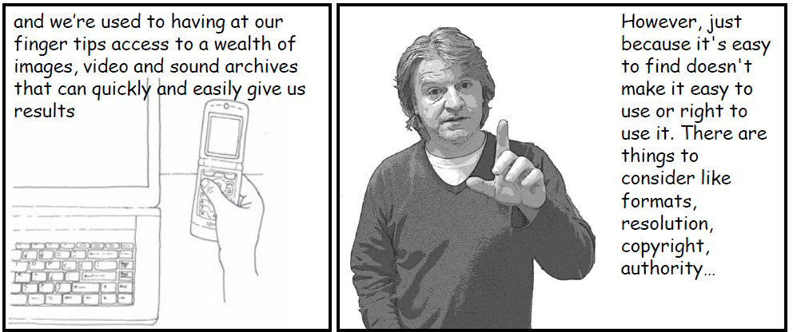
We used examples of external sources of video, sound and images materials which have good provenance and have appropriate rights cleared. Original materials were also designed. For maximum flexibility, we used PowerPoint, so that the final product can be printed or consulted electronically as a PDF file.

Evaluation approach
The evaluation was located in the interpretive paradigm, and took the form of a case study using a hybrid approach to data collection, to ensure optimal validity. The aim for deploying a mixed-method strategy was essentially ‘complementarity, or examining overlapping and different facets of a phenomenon’ (Tashakkori and Teddlie 1998:43).

Undergraduate focus groups (in two phases)
Ten students volunteered to participate in the evaluation. The group covered a range of disciplines and levels of study, as shown in the table below.
Table 1: composition of the undergraduate focus group
Course | Year | No. of students
BA Hons Planning Studies | 2 | 4
BSc Business Modelling and Management | 4 | 1
BSc Business and ICT | 1 | 1
BSc IT Management | 1 | 1
BA Business and HRM | 4 | 1
MSc IT | 1 | 1
MSc Pharmacology | 1 | 1
At the time of volunteering they were unaware of the nature of the activity. At the beginning of Phase 1 of the focus group, students were given a brief introduction with the minimum of information as to the purpose of the focus group. They undertook an activity which required them to find ‘visual material’ to enhance what was presented as the first page of a formally assessed assignment on cycling helmets. They were also asked to make a note of what they did. The students then undertook a very short self assessment of their IT and media literacy skills.
Phase 2 stared with giving students an explanation of the purpose of the focus group (using and evaluating VIA). The students then worked through VIA and then repeated the activity, again making a note of the steps they took.
Figure 2: Students working with VIA (phase 2)
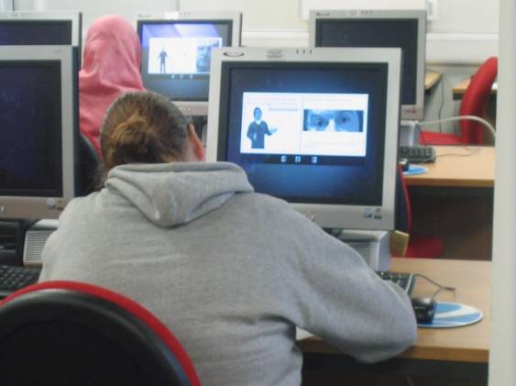 | 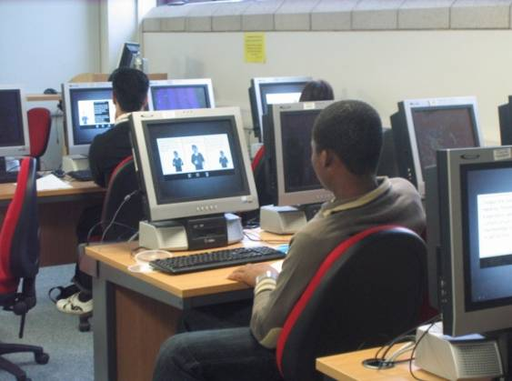
To complete phase 2, students were divided into two groups for a discussion about what they had learnt, the usability of the material and the content of the material.

Online heuristic evaluation by Master’s students
Students enrolled on the MA Professional Communication programme were invited to evaluate the VIA resource, as part of their studies on the ‘Visual Communication’ module. Seven students agreed to contribute (four women and four men) to the evaluation.
Their task was to select a visual analysis tool (e.g. Kostelnick and Roberts 1998; Rose 2007) and use heuristically to comment on the appropriateness of the VIA resource for a student audience. Heuristic evaluation is a method for assessing design quality in the user interface of software applications or websites (Dumas and Redish 1999; Nielsen and Mack 1994). It is carried out by several evaluators who, in parallel, assess the interface using a set of principles (or ‘heuristics’). Several evaluators are needed because a single evaluator cannot identify all possible problems. Each evaluator works alone, evaluating the interface against a list of heuristics, normally well established principles. Findings are aggregated, to identify the commonality and severity of the problems they have identified. In the case of our study, MA students took on the role of evaluators, and reported their conclusions in a discussion on the Blackboard site support their studies.

Online interviews with Information Advisers
The third group of people who evaluated the VIA resource were Information Advisers. These are information professionals who are either based in a faculty team, working closely with teaching staff to tailor information skills sessions to meet the needs of the specific cohort of students, or based in a functional team ensuring services, systems, and processes best meet teaching and learning needs. Each year they deliver approximately 1,500 hours of information literacy sessions, across all levels from Level 4 to postgraduate.
Table 2: composition of the Information Advisers’ panel
Team | Number of Information Advisers
Head of Academic Services | 1
ACES Faculty team | 1
Health and Wellbeing Faculty Team | 2
Sheffield Business School Team | 1
Systems Team | 1
Virtual Learning Centre Team | 2
Information Advisers were asked to evaluate VIA and provide feedback on the scope of the content, its value as a tool for developing media literacy skills, and also the overall look, feel and navigability of the resource.

Findings and discussion

Overall
On balance, feedback was positive. We received useful suggestions for improvements, such as: consistency in the use of the comic metaphor, replacement of idioms, addition of branding and ownership, more use of colour to aid navigation, value of some reference links. Comments on the resource name prompted to give a more meaningful title, so that 'Click, copy, create' became 'VIA' (‘Video, Images and Audio)'

Undergraduate perspectives
The students assessed their IT skills as either good or very good. Nine of the ten students had been asked to insert images into their coursework, and had on other occasions chosen to do so on their own initiative in order to enhance their work.
In phase 1 of the focus group, all students chose to search for a graphic and their approach was to use Google. Issues such as copyright, referencing and technical information were not addressed.
In phase 2, after using VIA, students selected from the wider range of resources which they had been introduced to. In their commentaries on the second attempt:
- one student mentioned that is “not right to copy and paste information”
- one student took on board technical information about size, colour, and distortion
- one student used “academic resource” in their list of search words for Google.
The second attempts also included some form of referencing for the image, either immediately under the picture or at the end of the document.
In summary all students were positive and offered comments such as “not bad”, “like it the way it is”. They liked the look though most would have liked colour to be used, finding the grey “unattractive”. Navigation was easy, but it was difficult to go back or to remember how far back something was. They liked the friendly language used and one commented positively on the “use of the man who seems to be explaining things”. The amount of context was “about right”, but the mention of semiotics put students off even though they understood the point of tailoring a message to an audience. The importance of sourcing and acknowledging the source was clearly recognised.
Feedback from the undergraduate focus group was used to amend VIA before the next phase of the evaluation by MA students.

MA students’ perspectives
Of the three groups of participants, this was the most negative overall – perhaps because they were asked to evaluate VIA as an artefact, rather than as a tool to support their learning. Also, they worked with a visual analysis grid, which encouraged critical evaluation.
Overall, the product was deemed well targeted at its audience and the visual delivery was essentially appropriate. For most students, the combination of visuals and text was seen a particular strength: “The text and the images complement each other very well throughout the document” (Student P). Yet this was not everyone’s preference: Student J thought the resource could be presented more succinctly as a series of bullet points, particular for mature students. While Student P agreed about the length, she believed that “a mixture of text and pictures” was appropriate.
The most commonly discussed feature was the use of an “anchor man”: this was mostly seen as a success factor because he “leads the user throughout the entire document... [and] contributes to ethos as he establishes a “visual connection” with the audience/user” (Student C); his “posture and gestures... reinforce what the text is stating or asking” (Student P). However, Student J (an older learner) felt the anchor man’s presence “insulted his intelligence”.
The MA students identified a number of areas where revisions could be made:
- The ‘iPhone’ format should either be discarded in the first two pages, or kept throughout the 54 pages (Students S and J)
- navigation was perceived as somewhat problematic, notably across the different chapters and with the 'home page'; however, the navigation icons “are immediately recognisable as they are the same icons commonly found on videos, computers, etc” (Student P)
- typographic choices needed to be more limited, to create consistency across the VIA resource, but the choice of Comic Sans MS was seen as “juvenile” (Student S and J) or apposite because it “establishes a ‘colloquial’ tone to the document which is in line with the target audience” (Student C)
- the use of the SHU logo needs to be more carefully considered
- format issues were also considered; notably, Student C suggested to “give the user the choice to either select a Flash format with real video and sound extracts, or a static HTML format which would include a downloadable PDF at the end in case the user needs to print it out or send it via email” – a view supported by other students.

Information Advisers’ perspectives
Overall, Information Advisers thought the content was comprehensive with the right level of information and detail; the comic style approach had unanimous appeal. One said that “the links to external resources are good too and provide a different approach and further information if you need to follow it.” The Adviser who supports the Arts area said she would use it within her literacy sessions, and others said they would find it useful to refer lecturers and students to should the need arise. Another Adviser said “the knowledge contained within the resources is very useful for myself.”
As in the other two sets of participants, opinion was divided in some aspects. For example, whilst one Adviser favoured the predominantly black and white approach with colour only used to add impact, the others thought more use of colour would improve the resource. One person said navigation was easy, but several people commented that they couldn't navigate to specific sections (clearly they hadn't realised that it is possible to do so from the 'menu' on the opening screen).

Conclusions
The Project Team remained focused, worked well together and produced a valuable resource within the budgetary constraints. In the early planning stages there was a temptation for enthusiasm to push the boundaries of the project; the scope had to be redefined to a realistic level for the time and resources available. Even so, we underestimated the time need for the production. In trying to be all encompassing the end product may not have as great an impact as it would if it had been targeted at a specific subject group and had greater depth. Overall the VIA resource was well received by the three user groups involved, in the sense that the resource helped develop awareness of media resource use. A number of presentational issues were noted (and acted upon) but these did not deter from the main messages.

Further Development
Keeping VIA up-to-date is essential. Whilst the basic principles will remain true, external links to useful 'tools' and sources of reusable materials will need to be reviewed and updated over time. This work will be undertaken by the Media Materials and Copyright Team and can easily be done as the resource has been developed in an editable format. However, the impact and value of VIA will only be realised if the resource is widely available. Learning and Information Services are currently working on an Information Literacy Strategy and as part of that project are looking to bring together the full range of resources and learning objects which have been developed to enable the development of literacy skills. VIA will be included in that portfolio and thereby made widely available to the SHU community.

Further reading
Purdy, L., Quinn, S., Dujardin, A.-F., and Cunliffe-Charlesworth, H. (2009) Click copy, create; media literacy skills for discovering, evaluating and reusing sound and visual resources. Sheffield Hallam University CETL event, Sheffield 17 July 2009

References
Dumas, J. S. and Redish, J. C. (1999) A Practical Guide to Usability Testing. Exeter: Intellect.
Kostelnick, C. and Roberts, D. D. (1998) Designing Visual Language: Strategies for Professional Communicators. Longman (Allyn and Bacon).
Little, D. (Ed.) (2003) Learner Autonomy in Foreign Language Classrooms: Teacher, Learner, Curriculum and Assessment. Dublin: Authentik.
Nielsen, J. and Mack, R. L. (1994) Usability Inspection Methods. New York, NY: Wiley.
Rose, G. (2007) Visual Methodologies: An Introduction to the Interpretation of Visual Methods. 2nd ed. London: Sage.
Scharle, A. and Szabo, A. (2000) Learner Autonomy: a Guide to Developing Learner Responsibility. Cambridge: Cambridge University Press.
Tashakkori, A. and Teddlie, C. (1998) Mixed Methodology: Combining Qualitative and Quantitative Approaches. London: Sage.
Thanasoulas, C. (2000) What is learner autonomy and how can it be fostered? Available at <http://iteslj.org/Articles/Thanasoulas-Autonomy.html>. [Last accessed November 2006]
Wilcox, S. (1996) 'Fostering self-directed learning in the university setting'. Studies in Higher Education, 21 (2): 165-176.

